Rotary Club of Lynnwood
P.O. Box 5856 Lynnwood, WA 98046-5856

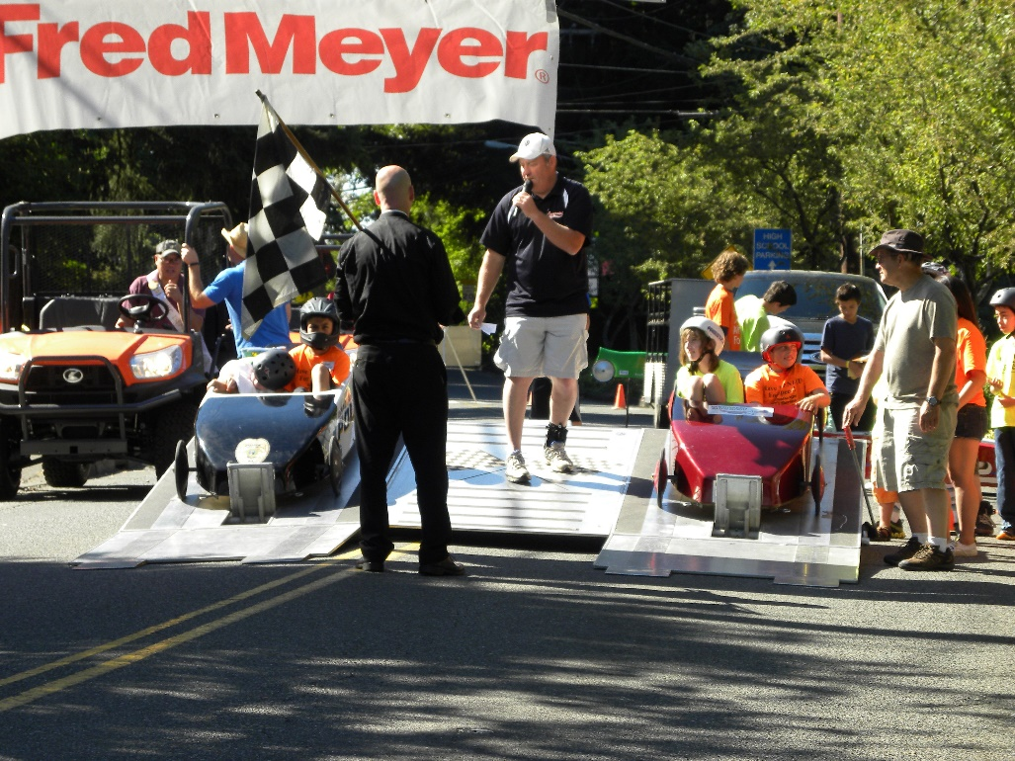
Challenge Series Races- June 5th, 2016

Media Sponsor
In exchange for local newspaper coverage, print and /or electronic, before, during and following the race, the media sponsor will receive the following:
- Inclusion in all race promotions and advertising, including on Race Shirts for all drivers, co-drivers and volunteers
- A vinyl full color ad on two race cars
- Name and representative announced to crowd and invitation to be guest starter for two heats

