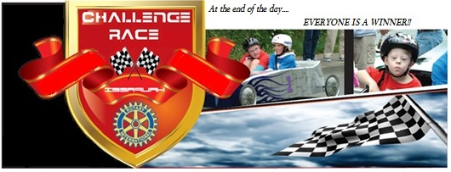
Rotary Club of Lynnwood
P.O. Box 5856 Lynnwood, WA 98046-5856
2016 Challenge Series Races- June 5th, 2016
IT IS EASY TO BECOME A SPONSOR

Starting Line Sponsor- $1000
The sponsor will receive:
- Name and logo prominently displayed on the banner over the starting line
- A vinyl full color ad of approximately 12”x24” on two race cars
- Name and logo on full color hay bale cover on the race course
- Representatives of the sponsor will be the guest starters of four race heats
- Inclusion in all race promotions and advertising, including on Race Shirts for all drivers, co-drivers and volunteers
- Opportunity to have an activity booth
Race Car Sponsor- $500
The sponsor will receive:
- A vinyl full color ad on two race cars
- Logo and name included in all race promotions and advertising, including on Race Shirts for all drivers, co-drivers and volunteers
- Invitation to be a guest starter at two race heats

Course Sponsor- $250
The sponsor will receive:
- Name and logo in full color on re-usable heavy vinyl cover for hay bale on course
- Logo and name included in all race promotions and advertising, including on Race Shirts for all drivers, co-drivers and volunteers
- Invitation to be a guest starter at one race heat

Heat Sponsor - $100
The sponsor will receive:
- Name and representative announced to crowd and invitation to be a guest starter at one race heat.

Thank you

