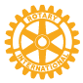Rotary Club of Lynnwood
P.O. Box 5856 Lynnwood, WA 98046-5856

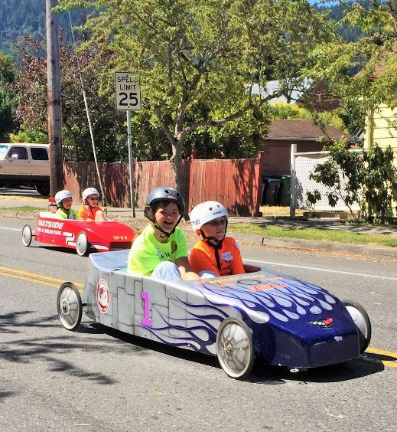
The Rotary Club of Lynnwood Challenge Series Race

The first Annual Rotary Club of Lynnwood’s Challenge Race is scheduled for Sunday, June 5th, 2016 and we are hoping that you will want to join in the fun.
This terrific event allows participants with disabilities to experience the fun of a soapbox derby race and each child has the great experience of the thrill of victory!
For the race, two children climb into the seat of a sleek soapbox derby type car. With the slam of the starting gate, the car’s wheels begin to turn. As gravity kicks in, the two-seater dashes along with the non-disabled child at the wheel and the co-driver with the disability an integral part of the team and the ride.
The Rotary Club of Lynnwood is partnering with Life Enrichment Options in order to offer this great experience for children with disabilities. Life Enrichment is donating the soap box derby cars for Rotary’s use.
Come join the fun on June 5th as one of our event sponsors and bring a smile and a terrific sense of pride and accomplishment to a child from our community!

Supporting 